Courier Management System (CMS)

TEAM MEMBERS

MANIGANDAN . A
GOWTHAM . G
JAYARAMAN . I
KISHORE . R
KRISHNAN . G

INTRODUCTION

Project Overview :
Courier and logistics companies face challenges in efficiently managing shipments and deliveries due to manual operations and disconnected systems. These issues lead to delayed updates, poor customer visibility, and operational inefficiencies.
The Courier Management System (CMS) is a Salesforce-based cloud solution that centralizes shipment booking, tracking, delivery agent assignment, automated status updates, billing, and analytics. The system improves operational efficiency, enhances customer satisfaction, and provides real-time business insights.

Purpose :

The purpose of the Courier Management System (CMS) is to automate and centralize courier and logistics operations using the Salesforce platform. The system aims to replace manual and fragmented processes with an integrated digital solution that enables efficient shipment booking, real-time tracking, delivery agent assignment, automated notifications, billing, and performance reporting. By providing a single, unified platform for managing shipments across multiple branches, CMS improves operational visibility, enhances customer communication, reduces delays and errors, and supports faster decision-making through analytics. Ultimately, the system is designed to increase service efficiency, customer satisfaction, and overall business profitability.

Solution Architecture
Components:
    - Customer Object
    - Shipment Object
    - Delivery Agent Object
    - Branch Object
    - Delivery Update Object
    - Invoice Object
    - Flows
    - Reports
    - Dashboards

Custom Objects Created:
- Customer c – stores customer personal and contact information
- Shipment c – manages parcel details, source, destination, and tracking information
- Delivery_Agent c – maintains delivery agent profiles and branch details
- Branch c – represents courier branch offices
- Delivery_Update c – stores status updates for each shipment
- Invoice c – manages billing details for delivered shipments

Relationships:
Customer → Shipment (Lookup) Shipment → Delivery_Agent (Lookup) Delivery_Agent → Branch (Lookup)
Delivery_Update → Shipment (Master-Detail) Invoice → Shipment (Lookup)

Milestone 3 - Tabs

Tab:
Tabs in Salesforce help users view the information at a glance. It displays the data of objects and other web content in the application.

Activity 1: Creating a Tab for Customer Object

Activity 2: Creating a Tab for Shipment Object

Activity 3: Creating a Tab for Delivery Agent Object

Activity 4: Creating a Tab for Branch Object

Activity 5: Creating a Tab for Delivery Update Object

Activity 6: Creating a Tab for Invoice Object

Fields & Relationships

What are fields ?

Activity 1: Creation of fields for the Customer Object

Field Name | API Name | Data Type | Required | Description
Customer Name | Name | Text | Yes | Full name of customer
Email | Email c | Email | Yes | Customer email
Phone | Phone c | Phone | Yes | Customer contact number
Address | Address c | Text Area | Yes | Customer address
Customer Type | Customer_Type c | Picklist | Yes | Regular / Business
City | City c | Text | No | Customer city
State | State c | Text | No | Customer state
Pincode | Pincode c | Text | No | Postal code
Is Active | Is_Active c | Checkbox | No | Active status

Activity 2: Creation of fields for the Shipment Object

Field Name | API Name | Data Type | Required | Description
Tracking Number | Name | Auto Number | Yes | Unique ID
Customer | Customer c | Lookup(Customer) | Yes | Related customer
Source Address | Source_Address c | Text Area | Yes | Pickup location
Destination Address | Destination_Address_  _c | Text Area | Yes | Delivery location
Weight | Weight c | Number | Yes | Parcel weight
Price | Price c | Currency | Yes | Shipping charge
Status | Status c | Picklist | Yes | Shipment status
Expected Date | Expected_Date c | Date | Yes | Delivery estimate
Assigned Agent | Assigned_Agent c | Lookup(Delivery_Age nt) | No | Delivery agent
Shipment Type | Shipment_Type c | Picklist | Yes | Domestic/International

Activity 3: Creation of fields for Delivery_Agent Object
Field Name | API Name | Data Type | Required
Agent Name | Name | Text | Yes
Email | Email c | Email | Yes
Phone | Phone c | Phone | Yes
Branch | Branch c | Lookup | Yes
Status | Status c | Picklist | Yes
Joining Date | Joining_Date c | Date | No

Activity 4: Creation of fields for Branch Object
Field Name | API Name | Data Type | Required
Branch Name | Name | Text | Yes
Branch Code | Branch_Code c | Text | Yes
City | City c | Text | Yes
State | State c | Text | Yes
Manager Name | Manager_Name c | Text | No

Activity 5: Creation of fields for Delivery_Update Object

Field Name | API Name | Data Type | Required
Update Number | Name | Auto Number | Yes
Shipment | Shipment c | Master-Detail | Yes
Status | Status c | Picklist | Yes
Update Date | Update_Date c | DateTime | Yes
Remarks | Remarks c | Text | No

Activity 6: Creation of fields for Invoice Object

Field Name | API Name | Data Type | Required
Invoice Number | Name | Auto Number | Yes
Shipment | Shipment c | Lookup | Yes
Amount | Amount c | Currency | Yes
Invoice Date | Invoice_Date c | Date | Yes
Payment Status | Payment_Status c | Picklist | Yes

Relationships :

Child Object | Field | Parent Object | Type
Shipment | Customer c | Customer | Lookup
Shipment | Assigned_Agent c | Delivery_Agent | Lookup
Delivery_Agent | Branch c | Branch | Lookup
Delivery_Update | Shipment c | Shipment | Master-Detail
Invoice | Shipment c | Shipment | Lookup

Validation Rules :
Validation rules are applied when a user tries to save a record and are used to check if the data meets specified criteria. If the criteria are not met, the validation rule triggers an error message and prevents the user from saving the record until the issues are resolved.

Activity 1: Create Validation Rules on Customer c
Check Active
In Error Condition Formula, paste: ISBLANK(Email c)

Validation Rule: Phone Must Be 10 Digits

Formula:
LEN(Phone c) <> 10

Validation Rule: Pincode Must Be 6 Digits

Steps:

Formula:
LEN(Pincode c) <> 6

Activity 2: Create Validation Rules on Shipment

Validation Rule: Weight Must Be Greater Than Zero

Formula:
Weight c <= 0

Validation Rule: Price Must Be Greater Than Zero

Steps:

Formula:
Price c <= 0

Validation Rule: Expected Date Cannot Be in the Past

Formula:
Expected_Date c < TODAY()

Activity 3: Create Validation Rules on Delivery_Agent

Validation Rule: Email Must Be Valid

Steps:

Formula:
NOT(CONTAINS(Email c, "@"))

Activity 4: Create Validation Rules on Branchc

Validation Rule: Branch Code Must Not Be Blank

Formula:
ISBLANK(Branch_Code c)

Activity 5: Create Validation Rules on Delivery_Update

Validation Rule: Remarks Required If Status is Delayed

Steps:

Formula:
AND(
ISPICKVAL(Status c, "Delayed"), ISBLANK(Remarks c)
)

Milestone 6 - Page Layouts :
Page Layouts in Salesforce control what a user sees on a record page and how information is organized.
They help structure fields, sections, buttons, related lists, and other components in a clean and user-friendly way.
By customizing page layouts, we ensure that users can easily enter, update, and view the required data.

Activity 1: Edit Page Layout for Customerc

Steps:

Section 1: Customer Information
  - Customer Name
  - Customer Type
  - Email
  - Phone
  - Is Active

Section 2: Address Details
  - Address
  - City
  - State
  - Pincode
- Edit the layout as needed
- Click Save.

Activity 2: Edit Page Layout for Shipment_c

Sections to Add:
Section 1: Shipment Details
  - Tracking Number
  - Customer
  - Shipment Type
  - Weight
  - Price
  - Status

Section 2: Address Information
  - Source Address
  - Destination Address

Section 3: Delivery Information
  - Expected Date
  - Assigned Agent
  - Arrange fields properly
  - Click Save

Milestone 7 - Flows
In Salesforce, a flow is a powerful tool that allows you to automate business processes, collect and update data, and guide users through a series of screens or steps. Flows are built using a visual interface and can be created without any coding knowledge.

Part 1: reate the Record-Triggered Flow
Step 1: Open Flow Builder
  - Click the Gear Icon → Click Setup
  - In the Quick Find box (left side), type Flows
  - Click Flows
  - Click the New Flow button
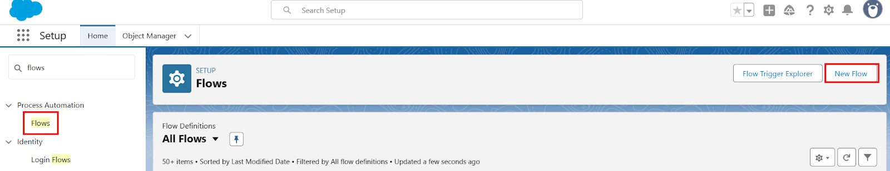

Final Flow Layout:
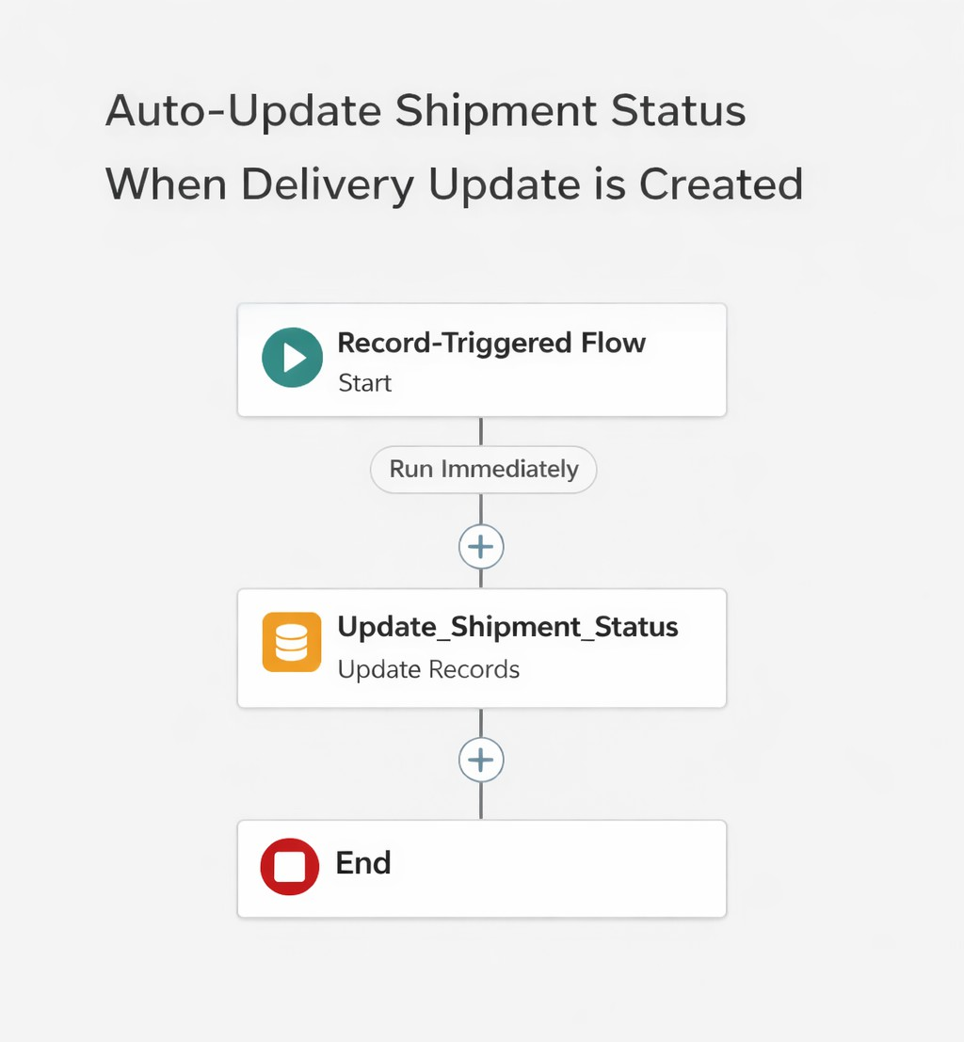
Milestone 8 - The Lightning App :

What is an App ?
Apps in Salesforce are a group of tabs that help the application function by working together as a unit. It has a name, a logo, and a particular set of tabs. The simplest app usually has just two tabs.

Milestone 9- Profile:

What is a profile?

A profile is a group/collection of settings and permissions that define what a user can do in salesforce. A profile controls “Object permissions, Field permissions, User permissions, Tab
settings, App settings, Apex class access, Visualforce page access, Page layouts, Record Types, Login hours & Login IP ranges.

Activity 1: Create a Custom Profile – Courier Admin

Create a Custom Profile:
- From Setup, enter Profiles in the Quick Find box.
- Click Profiles.
- Click New Profile.

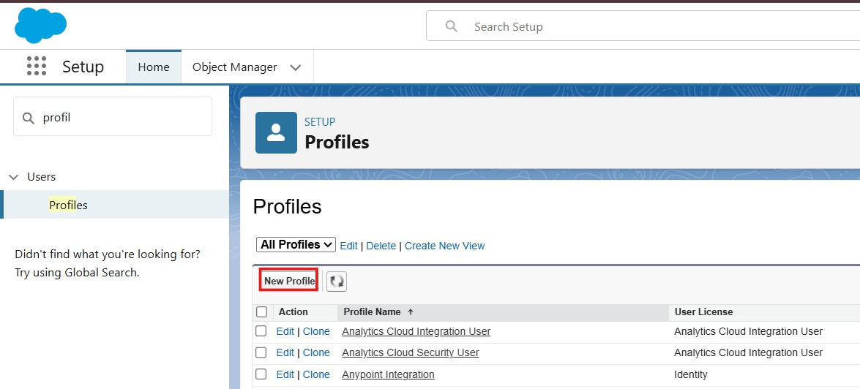

Set App & Tab Settings
Under Assigned Apps / Custom App Settings, set the default app to: Courier Management System App

Ensure Visible Tabs Include:
Set these tabs as Default On or Visible:
  - Customers
  - Shipments
  - Delivery Agents
  - Branches
  - Delivery Updates
  - Invoices

Milestone 10- Role:
In Salesforce, roles are used to determine which users have access to certain data and functions within the system. They are also used to define the reporting hierarchy within an organization. Users with higher roles have greater access to data and more control over the system.

- Click on Expand All and click Add Role under CEO.
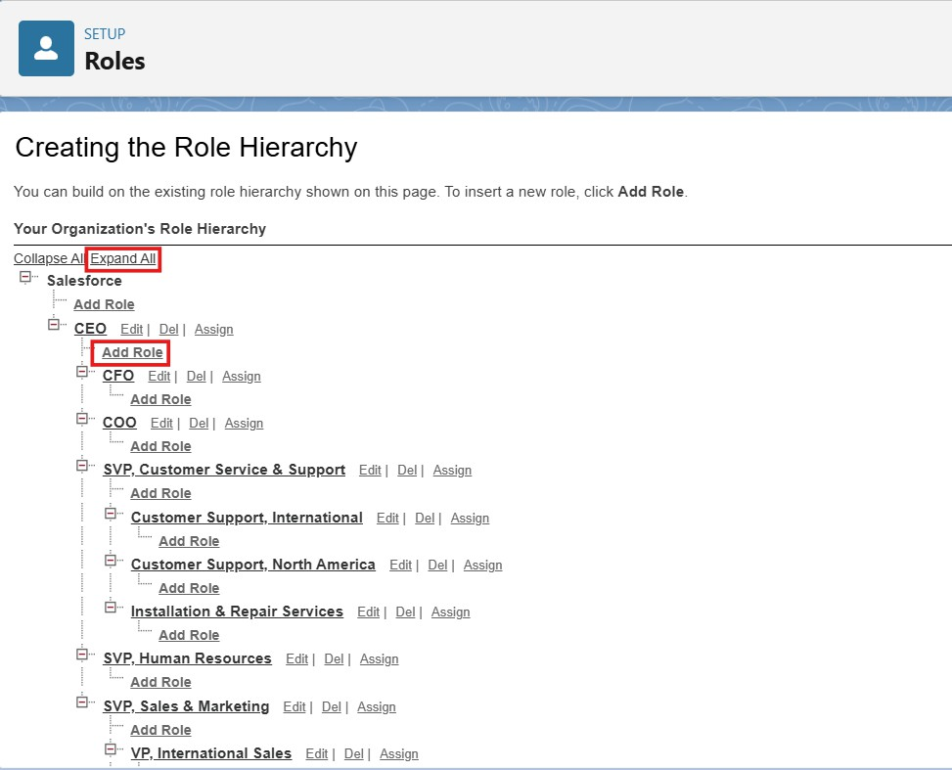
Purpose of This Hierarchy :
  - Courier Admin – Highest level access to all data
  - Branch Manager – Manages branch-level operations
  - Delivery Agent – Access only to assigned shipments
  - Customer Support – Limited access to customer and shipment tracking

This hierarchy ensures proper data sharing and security in the Courier Management System.

Milestone 11- User :

What is a user?
A user is anyone who logs in to Salesforce. Users are employees at your company, such as sales,reps, managers, and IT specialists, who need access to the company's records. Every user in Salesforce has a user account. The user account identifies the user, and the user account settings determine what features and records the user can access.

Activity 1: To Create a User

Steps:
- From Setup, enter Users in the Quick Find box, then select Users.

- Click New User.
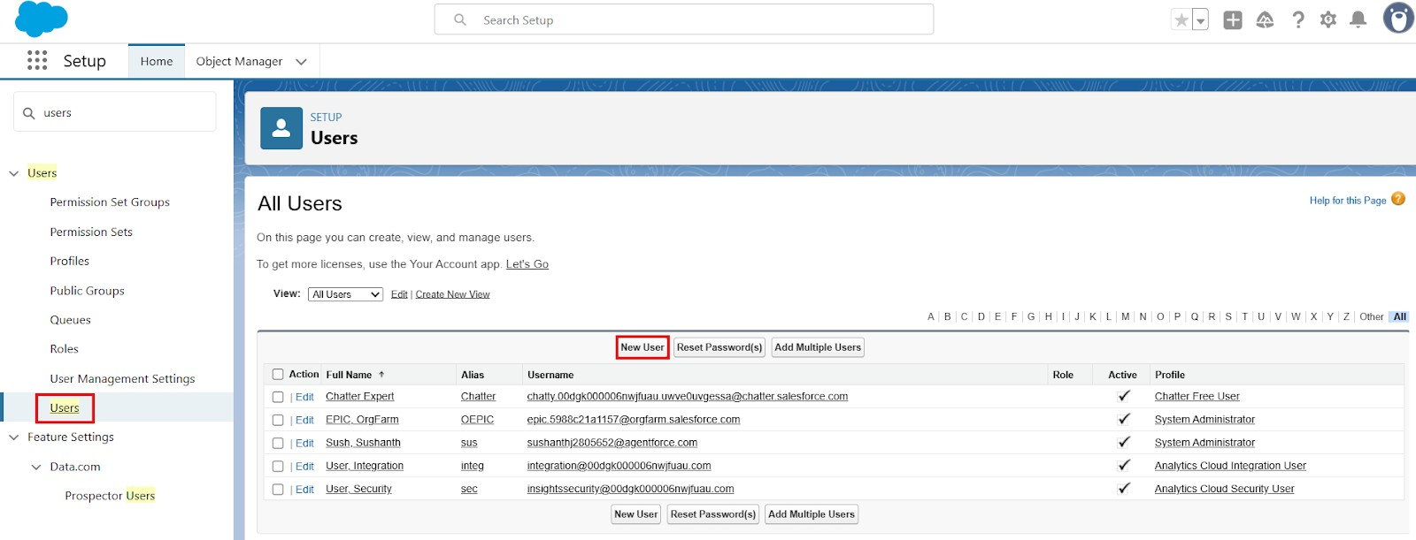

Milestone 15 : Reports & Dashboards
Reports and Dashboards help analyze business data and track courier operations efficiently.

Activity 1: Create Report Types

Step 1: Open Report Types
- Click Gear Icon → Select Setup.
- In Quick Find search Report Types.
- Click New Custom Report Type.

Activity 3: Create Dashboard

Step 1: Open Dashboards
- Click App Launcher (9 dots)
- Search Dashboards
- Click New Dashboard

Step 2: Enter Dashboard Details
  - Name: Courier Management Dashboard
  - Folder: CMS Reports
  - Click Create

Final Layout :
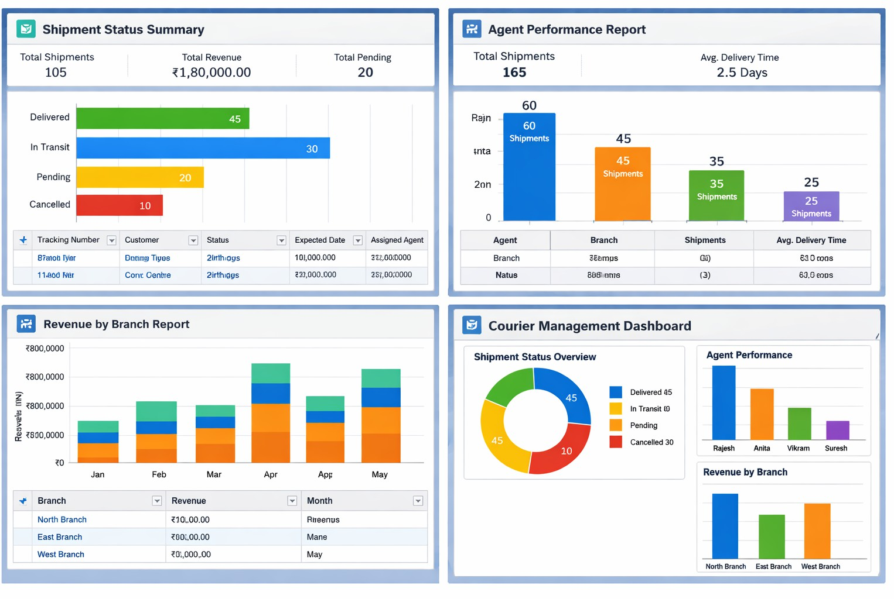

FUNCTIONAL & PERFORMANCE TESTING

During testing, screenshots were captured from Salesforce to verify record creation, validation rule enforcement, delivery status updates, flow automation, invoice generation, and dashboard visualization. All scenarios were validated to ensure correct performance and reliability.

- ADVANTAGES & DISADVANTAGES
Advantages
  - Centralized data
  - Automated workflows
  - Real-time reporting

Disadvantages
  - Salesforce dependency
  - Requires initial configuration effort

Conclusion:
The Courier Management System successfully digitizes courier operations using Salesforce automation, improving efficiency, accuracy, and customer satisfaction.

- FUTURE SCOPE
  - Mobile tracking app
  - GPS integration
  - SMS notifications
  - AI-based delivery optimization
- APPENDIX
  - Source Code: Salesforce Configuration
  - Dataset: Salesforce Objects
  - GitHub / Demo: Salesforce Developer Org
Thank You
